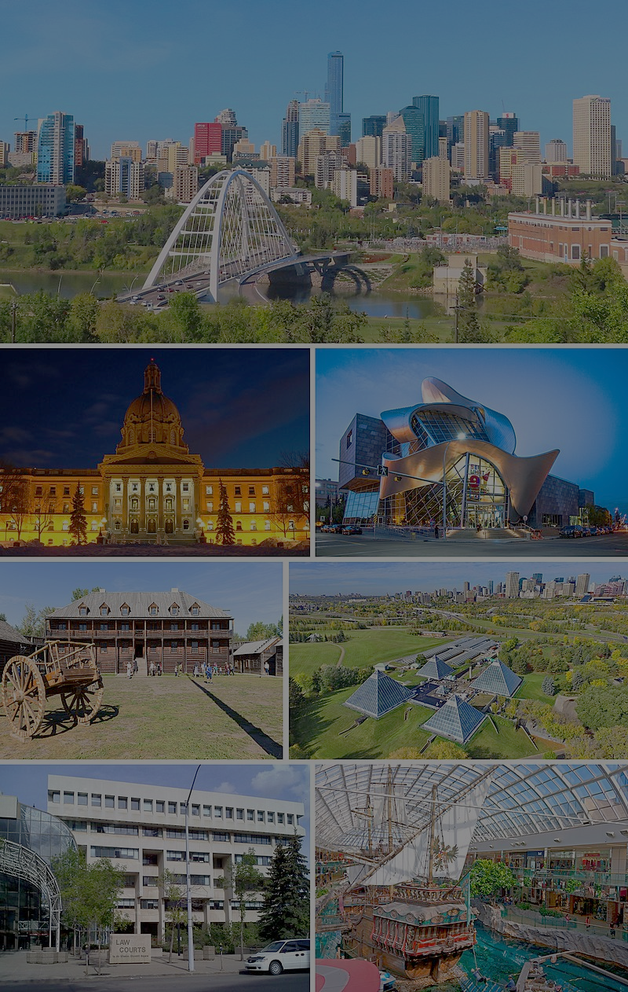**The Battle of Neighborhoods: Edmonton’s Best Neighborhood**

**By Armin Norouzi**

**Abstract:**

In this project first, the investigation on Alberta Capital city have been done to find out which neibouhoud has the best neibeohoud to live. To analyize this, Data from Wikipedia has used to generate Edmonton Neibhouds location information. Then, Foursquare API is employed to generate venued nearby each locatopn. At the end, thgree more desirable neibohoud in based on number of venue prospect have been idenfified.

1. **Introduction:**

Edmonton is the capital city of the Canadian province of Alberta. Edmonton is on the North Saskatchewan River and is the center of the Edmonton Metropolitan Region, which is surrounded by Alberta's central region. The city anchors the north end of what Statistics Canada defines as the "Calgary–Edmonton Corridor".

The metro area of Edmonton had a population of 1,491,000 at the beginning of 2021, making it Alberta's second-largest city (after Calgary) and Canada's fifth-largest municipality. Edmonton's 2019 municipal census subsequently recorded a population of 972,223. Also in 2016, Edmonton had a metropolitan population of 1,321,426, making it the sixth-largest census metropolitan area (CMA) in Canada. Edmonton is North America's northernmost metropolitan area with a population over one million. A resident of Edmonton is known as an Edmontonian.

Edmonton's historic growth has been facilitated through the absorption of five adjacent urban municipalities (Strathcona, North Edmonton, West Edmonton, Beverly and Jasper Place) in addition to a series of annexations through 1982, and the annexation of 8,260 ha (82.6 km2) of land from Leduc County and the City of Beaumont on January 1, 2019. Known as the "Gateway to the North",[18] the city is a staging point for large-scale oil sands projects occurring in northern Alberta and large-scale diamond mining operations in the Northwest Territories.

Edmonton is a cultural, governmental and educational center. It hosts a year-round slate of festivals, reflected in the nickname "Canada's Festival City". It is home to North America's largest mall, West Edmonton Mall (the world's largest mall from 1981 until 2004), and Fort Edmonton Park, Canada's largest living history museum.

The main purpose of this Project is to help people in exploring better facilities around their neighborhood. It will help people making smart and efficient decision on selecting great neighborhood out of numbers of other neighborhoods in Edmonton, Alberta.

This Project aim to create an analysis of features for a people migrating to Edmonton to search a best neighborhood as a comparative analysis between neighborhoods. The features include median housing price and better school according to ratings, crime rates of that particular area, road connectivity, weather conditions, good management for emergency, water resources both fresh and waste water and excrement conveyed in sewers and recreational facilities.

It will help people to get awareness of the area and neighborhood before moving to a new city, state, country or place for their work or to start a new fresh life.

1. **Data Section**

For this project we need the following data:

* New York City data that contains list Boroughs, Neighbourhoods along with their latitude and longitude.
* Data source : https://en.wikipedia.org/wiki/List_of_postal_codes_of_Canada:_T
* Description: This data set contains the required information. And we will use this data set to explore various neighbourhoods of Edmonton, AB, Canada
* Venue information in each neighbourhood of Edmonton.
* Data source : Foursquare API
* Description: By using this API we will get all the venues in each neighbourhood. We can filter these venues to get only Indian restaurants.
* GeoSpace data
* Data source : <https://data.cityofnewyork.us/City-Government/Borough-Boundaries/tqmj-j8zm>
* Description: By using this geo space data we will get the Edmonton Borough boundaries that will help us visualize choropleth map.

1. **Research Question**

The major purpose of this project, is to suggest a better neighborhood in a new city for the person who are shiffting there. Social presence in society in terms of like minded people. Connectivity to the airport, bus stand, city center, markets and other daily needs things nearby.

Edmonton is a popular destination for new immigrants in Canada to reside. As a result, it is one of the most diverse and multicultural areas in the Greater Edmonton Area, being home to various religious groups and places of worship. Although immigration has become a hot topic over the past few years with more governments seeking more restrictions on immigrants and refugees, the general trend of immigration into Canada has been one of on the rise.

This project would use Four-square API as its prime data gathering source as it has a database of millions of places, especially their places API which provides the ability to perform location search, location sharing and details about a business.

1. **Work Flow**

Using credentials of Foursquare API features of near-by places of the neighborhoods would be mined. Due to http request limitations the number of places per neighborhood parameter would reasonably be set to 100 and the radius parameter would be set to 700.

1. **Methodology**
   1. **Clustering Approach**

To compare the similarities of two cities, we decided to explore neighborhoods, segment them, and group them into clusters to find similar neighborhoods in a big city like New York and Toronto. To be able to do that, we need to cluster data which is a form of unsupervised machine learning: k-means clustering algorithm

* 1. **Libraries Which are Used to Develope the Project**

In this project varies Packages have been use that can be listed here:

* Pandas: For creating and manipulating dataframes.
* Folium: Python visualization library would be used to visualize the neighborhoods cluster distribution of using interactive leaflet map.
* Scikit Learn: For importing k-means clustering.
* JSON: Library to handle JSON files.
* XML: To separate data from presentation and XML stores data in plain text format.
* Geocoder: To retrieve Location Data.
* Beautiful Soup and Requests: To scrap and library to handle http requests.
* Matplotlib: Python Plotting Module.

1. **Results and Discussions**
   1. **Best Neiberhood**

Alberta Neibhoud and in different cities is shown in Figure 1.

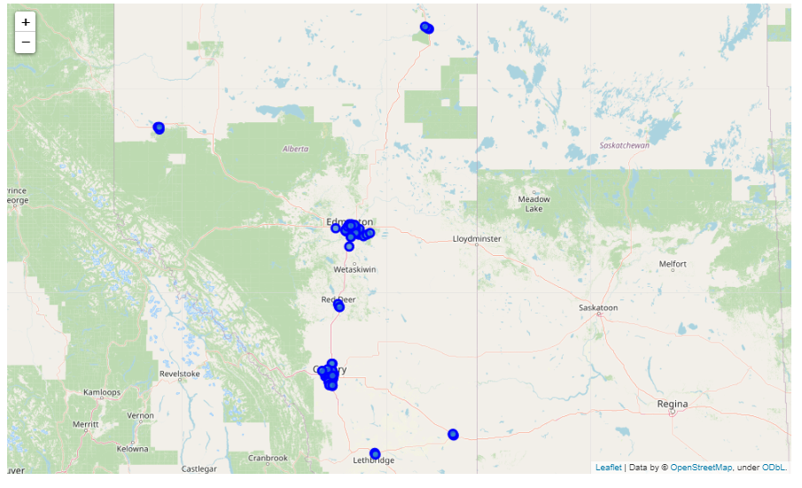

Figure 1- Alberta Map

As the main objective of this project is focusing on capital city of Alberta, we choose only postal codes that includes Edmonton in their Borough. The results shown as follow:

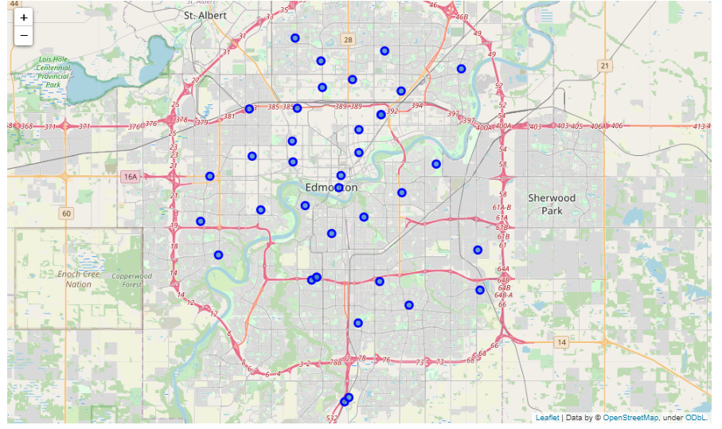

Figure 2- Edmonton Map

Then Foursquare API is employed to find the best neibouhood of edmontona bsed on number of venus. Follwong table shows the number of venus in 500 meters radius of each neiberhoud.

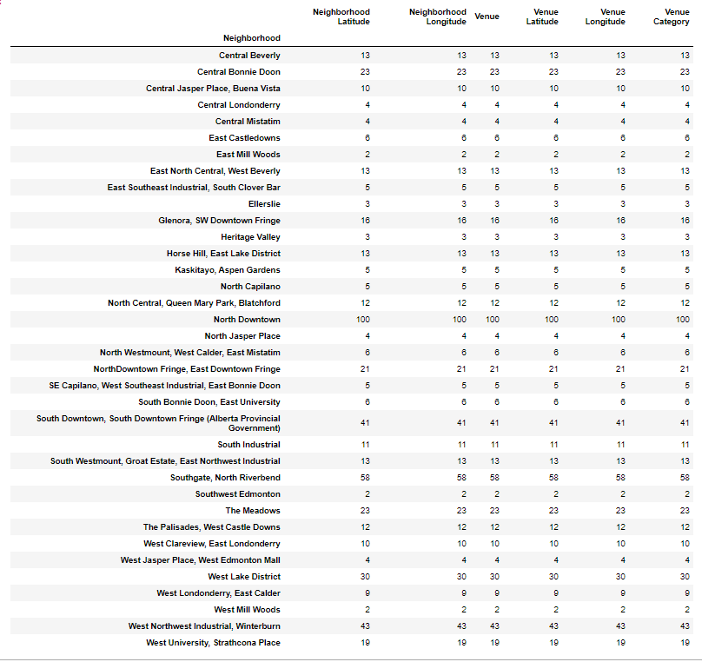

Based on this table, North Downtown has thehighest number of venue.

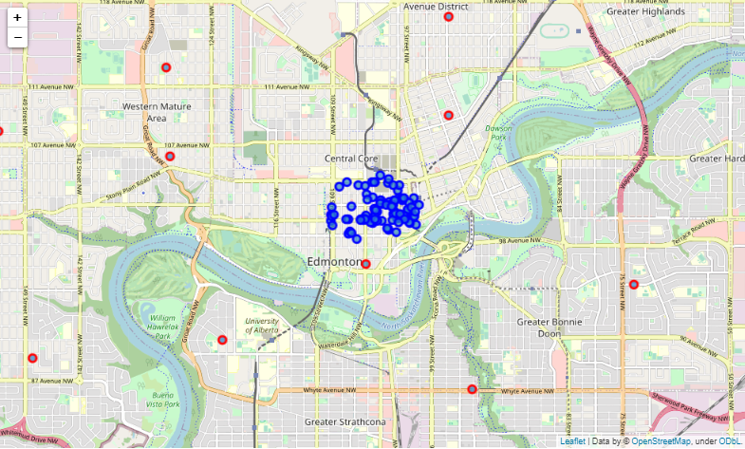

Figure 3- North Downtown Venus

These venus has been shown in the map in Figure 3. Top ten catoagories of these venuwe are listed as follow:

|  |  |
| --- | --- |
| **Venue catagory** | **Number in each catagory** |
| Coffee Shop | 9 |
| Sandwich Place | 5 |
| Pub  Café  Hotel | 4 |
| Restaurant  French Restaurant | 3 |
| Pizza Place  New American Restaurant  Rock Club  Brewery  Gym  Nightclub  Smoothie Shop  Asian Restaurant  Vietnamese Restaurant  Bar  Mexican Restaurant  Steakhouse | 2 |

* 1. **Most Common venues near neighborhood**

In this study K-means algorithms is used to find most common Neibearhouds. The results is shown in Figure 4. As shown, almost all the neibrhouds has the same catagories of venued all around the city that make this city desirable. It does not matter which part of cicye are you living, you have access to every venud,

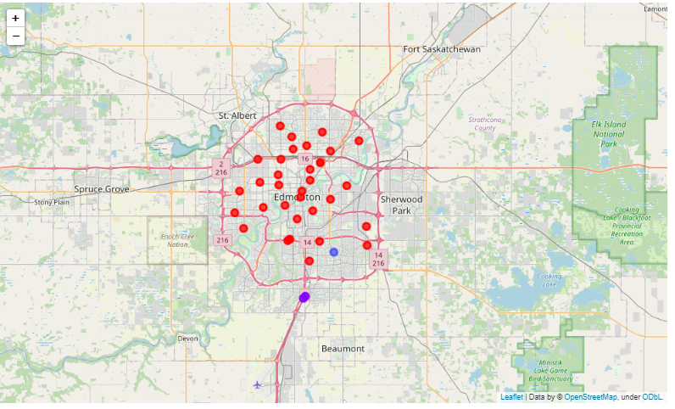

Figure 4- Clustering results